ArmPi Pro Camera Calibration

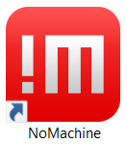In order to calibrate the Camera on the ArmPi pro robot you will need the following materials, assuming user has access to a laptop.

1. ‘NoMachine’ software in order to access the robots’ functions.

-Download ‘NoMachine’: <https://www.nomachine.com/>

1. Print out a 1:1 scale of the Calibration Board and lay flat on a surface. After, place ArmPi over Calibration Board where it seems symmetrical from End Effector to Calibration Board. Figure 1 demonstrates an example of the positioning.

-Note: If needed, user can run ‘GenerateCalibrationPlate.py’ to generate a Calibration Board.

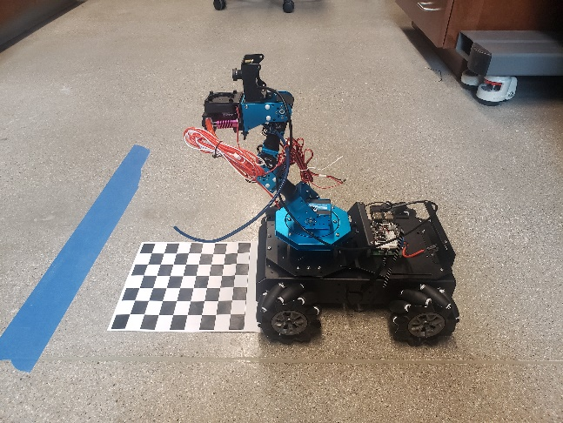 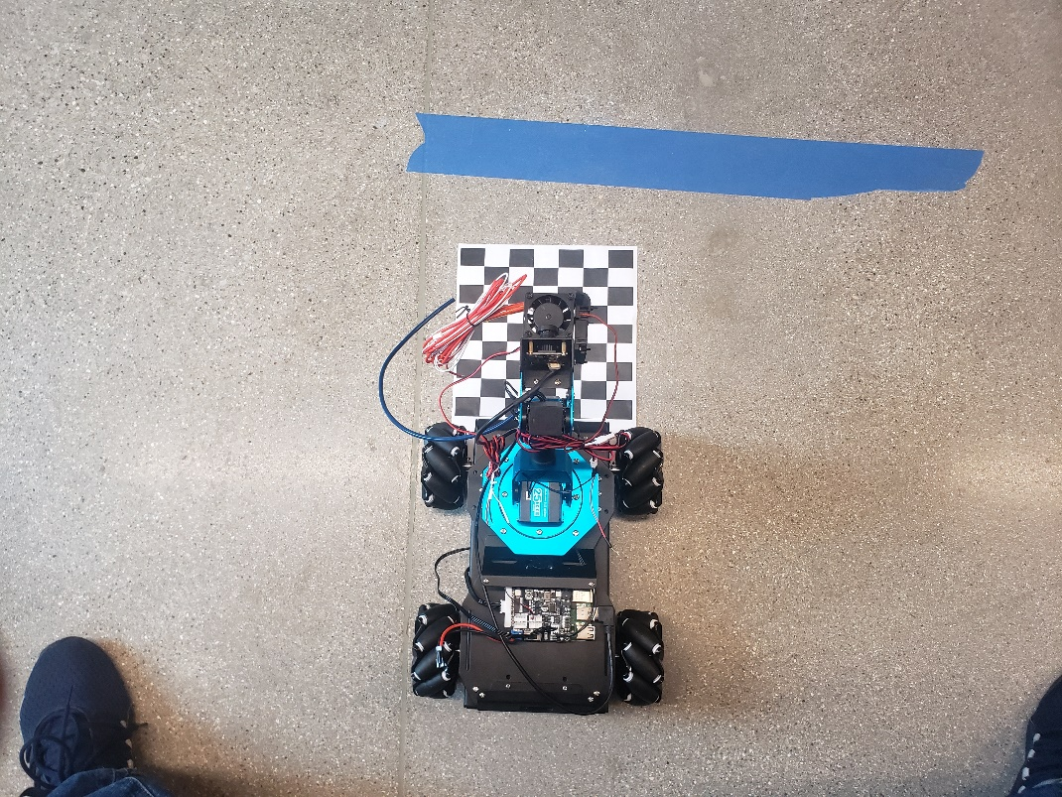

*Figure 1: Top and Side view Positioning of ArmPi Pro with Calibration Board.*

1. Run ‘CollectCalibrationPicture.py’ to open Camera window.
2. Open up PC_Software application, , through NoMachine and use your best judgement to adjust camera to have a full-centered view of the Calibration Board.
3. Go to Camera window and capture approximately 30 images of the Calibration Board. Rotate the board 90 degrees between multiple snaps and repeat Step (4). Figure 2 shows an example of the rotation. To capture images, you will need to press the ‘Spacebar’ key. -Note: It will number how many images have been capture at the top corner.

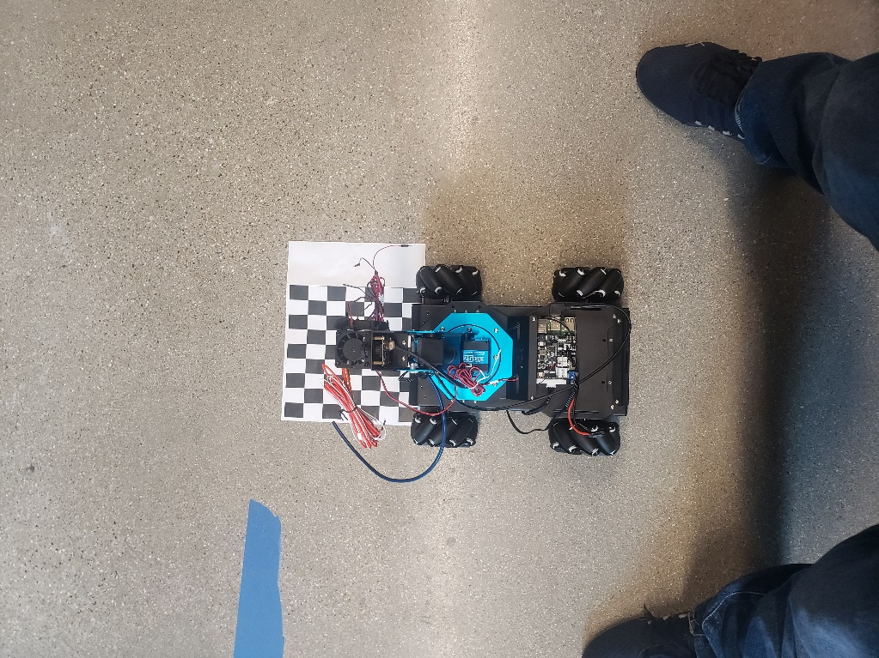 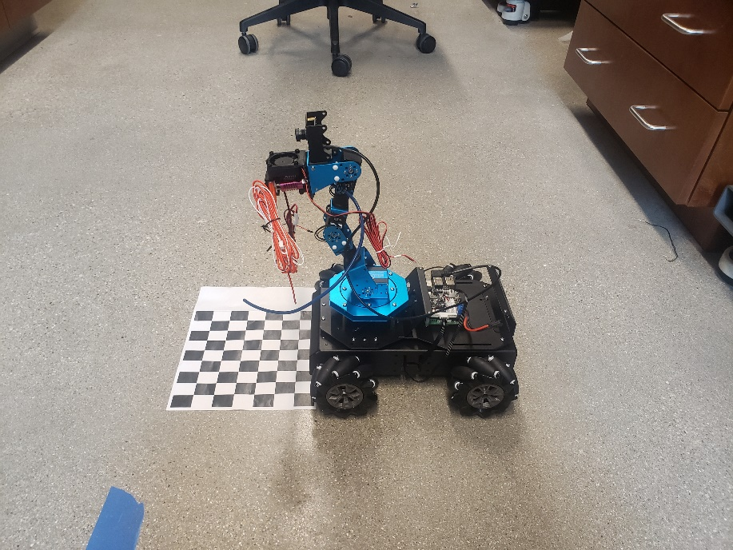

*Figure 2: Demonstration of Rotation of Calibration Board*

1. Once images have been captured run ‘Calibration.py’ to compile and upload all your captured images.
2. Run ‘TestCalibration.py’ ; This will display 2 camera windows. One is the **original** view you had prior to calibration of the camera and the other is the **new** view of the camera. If satisfied hit ‘Save’. Repeat Steps 3-6 if unsatisfied with image.